Business Requirement Document: Online Mock Test Website

Online Mock Test Website

Business Requirements Document (BRD)



1. **Document Revisions**

|  |  |  |
| --- | --- | --- |
| Date | Version Number | Document Changes |
| 07/03/2025 | 1.0 | Initial |
|  |  |  |
|  |  |  |
|  |  |  |
|  |  |  |
|  |  |  |
|  |  |  |
|  |  |  |
|  |  |  |

1. **Approvals**

|  |  |  |  |  |
| --- | --- | --- | --- | --- |
| **Role** | **Name** | **Title** | **Signature** | **Date** |
| Project Sponsor | Prof. Nguyen Duy Nghiem |  |  |  |
| Product Owner | Mr. Hoang Nhu Vinh |  |  |  |
| Project Manager | Mr. Quy Pham |  |  |  |
| Client | Miss.Van Anh |  |  |  |

1. **Introduction**

# Project Summary

The Online Mock Test System is a web-based platform designed to enable students to take mock tests in Reading, Listening, Writing, and Speaking skills. It provides tools for teachers to create, manage, and grade tests, and for administrators to oversee user accounts and system operations. The system aims to streamline the assessment process, offering students a means to practice and track their progress while supporting educators in delivering effective evaluations.

* + 1. Objectives
       - Provide students with an accessible platform to take mock tests and monitor their performance.
       - Equip teachers with efficient tools to design, schedule, and grade tests.
       - Enable administrators to manage users and maintain system integrity.
       - Ensure secure, reliable, and scalable operations to meet the demands of educational institutions.
    2. Background

With the rise of remote learning, there is a growing need for robust online assessment tools. The Online Mock Test System addresses this by offering a structured environment for students to enhance their skills and for educators to evaluate progress, replacing or supplementing traditional in-person testing methods.

* + 1. Business Drivers
       - Increasing demand for online education and assessment solutions.
       - Need for scalable, secure platforms to support large user bases.
       - Requirement to comply with data privacy regulations like GDPR.

# Project Scope

The scope of the project is to design and develop an online mock test website for the University of Greenwich. Teachers will be able to use the website interface to create tests for students. The web based admin interface will help the admin user i.e. business owner to manage teachers, and configure the system.

* + 1. In Scope Functionality
       - Students
         * User registration and authentication with OTP verification.
         * Access to test sessions using session keys.
         * Test-taking interface with time tracking and auto-save features.
         * Result notifications and performance tracking
       - Teacher
         * Test creation, scheduling, and management.
         * Automated grading for Reading and Listening tests.
         * Analytics and detailed performance reporting.
         * Manual grading for Writing and Speaking tests.
       - Admin
         * Teacher account management and system configuration.
    2. Out of Scope Functionality
       - Integration with external Learning Management Systems (LMS).
       - Development of a dedicated mobile application.

# User Roles

|  |  |
| --- | --- |
| **Role** | **Description** |
| **Students** | * Register. * Take mock tests. * View results. * Track performance over time. |
| **Teachers** | * Create and manage test sessions. * Grade subjective tests. * Monitor student progress. |
| **Admin** | * Manage teacher accounts. * Configure system settings. * Ensure security compliance. |

* 1. System Perspective
     1. Assumptions
        + Students have valid session keys to access test sessions.
        + Teachers are responsible for manually grading Writing and Speaking tests.
        + Email services are available for OTP verification and result notifications.
     2. Constraints
        + The system must support up to 10,000 concurrent users.
        + Compliance with GDPR for data security and privacy is mandatory.
        + Requires internet access and a compatible web browser.
     3. Risks
        + Security breaches if user data protection is inadequate.
        + System downtime impacting test availability or grading processes.
        + Insufficient training for teachers and administrators on system use.
     4. Issues
        + Ensuring timely manual grading of Writing and Speaking tests.
        + Maintaining performance during peak usage with large numbers of concurrent users.

1. **Business Process Overview**
   1. Proposed Business Process (To-Be)

* **Student Registration**: Students register and verify their accounts using OTP sent via email.
* **Test Creation**: Teachers create test sessions, generate session keys, and schedule tests.
* **Test Taking**: Students log in, enter the session key, and complete the test within the allotted time.
* **Grading**: The system auto-grades Reading and Listening tests; teachers manually grade Writing and Speaking tests.
* **Result Delivery**: Students receive results via email and can view their performance history in their profiles.
* **Administration**: Administrators manage user accounts and system settings as needed.

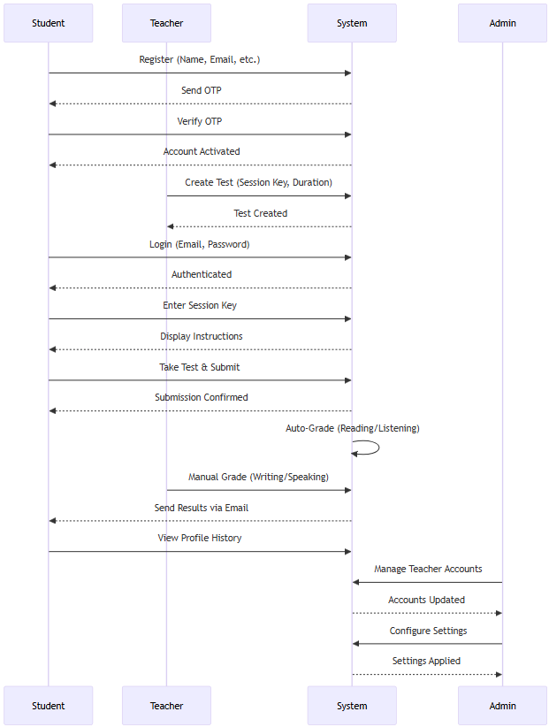

1. **Business Requirements**

The requirements in this document are prioritized as follows:

|  |  |  |
| --- | --- | --- |
| **Value** | **Rating** | **Description** |
| 1 | Critical | Most Urgent and most important requirements. |
| 2 | High | Urgent but not as critical requirements and important requirements |
| 3 | Medium | Important but not urgent requirements |
| 4 | Low | Low Important and not urgent requirements |
| 5 | Future | Future scope requirements. |

* 1. Functional Requirements

|  |  |  |  |  |
| --- | --- | --- | --- | --- |
| **Req#** | **Priority** | **Description** | **Rationale** | **Impacted Stakeholders** |
| FR-001 | 1 | User registration and authentication with OTP verification. | Ensures secure access for authorized users only. | Students, Teachers, Admin |
| FR-002 | 1 | Test creation and management tools for teachers. | Enables teachers to design and schedule tests. | Teachers |
| FR-003 | 1 | Test-taking interface with time tracking and auto-save. | Provides a seamless testing experience. | Students |
| FR-004 | 2 | Automated grading for Reading and Listening tests. | Delivers immediate feedback for objective tests. | Students, Teachers |
| FR-005 | 2 | Manual grading interface for Writing and Speaking tests. | Allows detailed evaluation of subjective tests. | Teachers |
| FR-006 | 1 | Result notification system via email and performance tracking. | Keeps students informed and engaged. | Students |
| FR-007 | 3 | Administrative tools for user management and system configuration. | Maintains system security and functionality. | Admin |

* 1. Non-Functional Requirements

|  |  |
| --- | --- |
| **ID** | **Requirement** |
| NFR-001 | The system shall support up to 10,000 concurrent users. |
| NFR-002 | Test pages shall load within 3 seconds under normal network conditions. |
| NFR-003 | User data shall be encrypted at rest and in transit. |
| NFR-004 | Multi-factor authentication shall be implemented for administrator accounts. |
| NFR-005 | The interface shall be responsive and accessible on desktop and mobile devices. |
| NFR-006 | The system shall maintain 99.9% uptime with daily automated backups. |
| NFR-007 | The system shall support updates without downtime and maintain audit logs. |

1. **Appendices**

# List of Acronyms

**OTP**: One-Time Password

**LMS**: Learning Management System

**GDPR**: General Data Protection Regulation

# Glossary of Terms

**Session Key**: A unique identifier required to access a specific test session.

**Mock Test**: A practice exam simulating real test conditions.

# Related Documents

Software Requirements Specification (SRS)

Technical Specification Document